Official league roster - Basketball
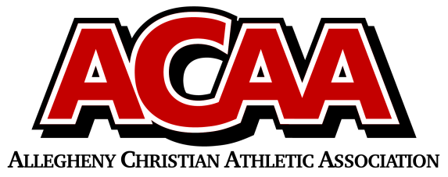

School Name: johnstown christian
Team Colors: royal blue and white
Overall Wins ___ Losses ____ Ties ___
ACAA Wins ___ Losses ____ Ties ___ OPPONENT: __________________________
Date: _________
Number | Name | Year | Position | Height | Homeschool
22 | Joseph Sorg | 12th | F
15 | Jaydon Yoder | 11th | G/F
14 | Daniel Harper | 10th | F
10 | Jeremiah Taylor | 10th | G
24 | Mathew Blough | 10th | F
13 | Brayden Kibbi | 10th | G
11 | Dijon Coleman | 9th | G
4 | Levi DiGuardi | 9th | G
23 | Keyahno Richardson-Toney | 9th | F/G
12 | Adam Habecker | 9th | F
21 | Elijah Swart | 9th | C

Head Coach: Andrew taylor
Asst. coach: Steve ledwich
Asst. coach: Kenyon Blough

Official ACAA League Team Roster. to be submitted to the scorer’s table before each game.

